Chapter 12 Review Exercise Solutions

R12.1

This book recommends the following object-oriented development process:
- Gather program requirements.
- Discover classes.
- Determine the responsibilities of each class and identify collaborating classes.
- Determine the relationships between the classes.
- Document the behavior of classes using javadoc comments.
- Implement classes.

R12.2

Classes correspond to nouns in the task description.

R12.3

Methods correspond to verbs in the task description.

R12.4

After discovering a method, it is important to identify the responsible object because it may need more than one method to carry out the task, and it may need to collaborate with other classes.

R12.5

- University–Student: aggregation; a university has students
- Student–TeachingAssistant: inheritance; a teaching assistant is a student
- Student–Freshman: inheritance: a freshman is a student
- Student–Professor: neither
- Car–Door: aggregation; a car has doors
- Truck–Vehicle: inheritance; a truck is a vehicle
- Traffic–TrafficSign: no relationship
- TrafficSign–Color; no relationship. (Color is an attribute)

R12.6

The class BMW can inherit from the class Vehicle–every BMW is a vehicle. However, the BMW company (which is different from the class of all BMWs) is an object of the class VehicleManufacturer. Inheritance is not appropriate for describing the relationship between an instance of a class (an object) and a class.

R12.7

The Circle.setLocation method needs to move the center of the circle; the radius is not affected. That is exactly what Point.setLocation does, so the method can be inherited.

However, a circle isn’t-a point, so it doesn’t make conceptual sense to use inheritance.

The other way around, it makes some conceptual sense. A point is a circle with radius 0. But then it becomes difficult to construct a circle using a point and a radius, since a point is defined only in terms of a circle. It makes more sense to define a class Point and a separate class Circle.

R12.8

Coin
get value
get name

CashRegister
record purchase | Coin
enter payment
give change

R12.9

Quiz
add question | Question
present questions

Question
set question text | String
set answer
check answer
display

R12.10

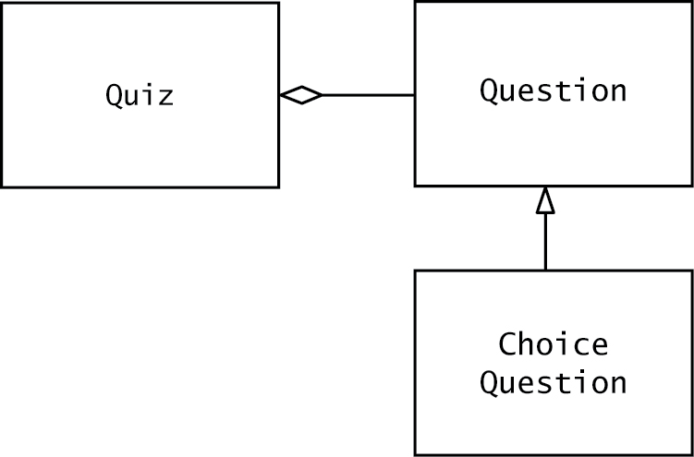

R12.11

Country
get area
get density
get name
get population

CountryReader
read file
get largest area | Country
get largest density
get largest population
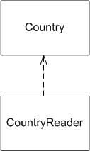

Country.html

CountryReader.html

R12.12

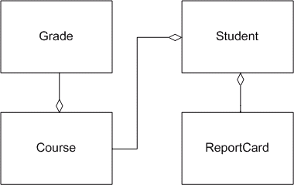

Student.html
Course.html
ReportCard.html
Grade.html

R12.13

One would expect a VendingMachine, Product class and Coin class.

R12.14

Answers can vary, but a possible design could use an Employee class to keep track of hourly rates and hours worked as well as a Paycheck class that would use an Employee class to generate a paycheck.

R12.15

